|  |
| --- |
| EPAM Systems, RD Dep. |
| MTN.BI.08 Dimension Table Techniques |

|  |  |  |  |  |  |
| --- | --- | --- | --- | --- | --- |
| REVISION HISTORY | | | | | |
| Ver. | Description of Change | Author | Date | Approved | |
| Name | Effective Date |
| 1.0 | Initial status | Hanna_Takushevich | 21-NOV-2017 |  |  |

Contents

1. Geo Hierarchy 3

2. Dimension Hierarchy Analysis 4

# Geo Hierarchy

Create denormalized countries query based on a normalized data on the staging layer.

Required points:

* Create denormalized structure data using CONNENT_BY

Add Additional Columns to table:

* Branch, ROOT, Leaf
* Count of children of Branch or Root
* Full path of Dependencies by Example: ROOT -> BRANCH -> BRANCH -> LEAF

Task Results:

* Script.
* Prepare document with description and screenshot of denormalized data

Для выполнения работы было создано представление со следующими данными:

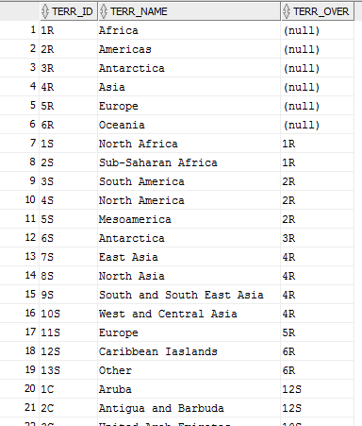

Результат работы скрипта для наглядной демонстрации иерархии:

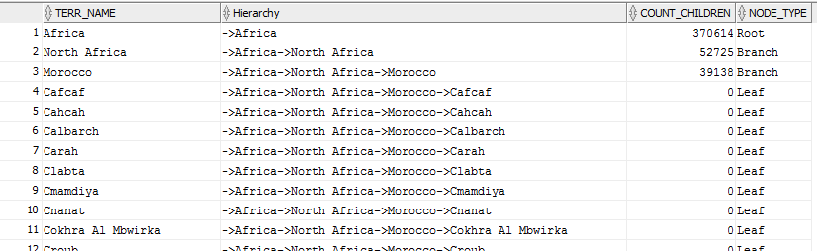

Скрипты находятся в папке с отчётом.

# Dimension Hierarchy Analysis

Apply same steps to any of your business' dimensions. Use recursive WITH clause instead of CONNECT BY.

Task Results:

* Script.
* Prepare document with description and screenshot of denormalized data.

Результат работы скрипта для наглядной демонстрации иерархии:

